Function Test Cases

The test is based on git of the version sprint01

Title: 001 First signup and signup successfully

Precondition: Database is created well and the communication function between server and client is also well

Expect Result: After you creating a personal account, you can check the information in database.

Steps:

1. AS shown in Figure 1-1, when you run this program, by typing Signup button on the above, enter the Signup screen
2. After you enter the Signup screen, you have to fill in the blanks in Figure 1-1 to signup
3. When you finish the above two steps, click the Signup button, if you were the first time to signup and every blanks were filled in right way, then you will can see the information to tell you that you are succeed to register, as shown in Figure 1-2

Actual Result:

When you check the information in the database that installed on the server, you can see the information you just typed in. For example, the username is cindy, email address is [cindy@tadosoft.com](mailto:cindy@tadosoft.com), password is 123,then you can see the following result:

| UID | UserName | Pwd | Email | CreateTime | UTypeID |

+-----+----------+------+--------------------+---------------------+---------+

| 1 | cindy | 123 | cindy@tadosoft.com | 2011-06-14 11:24:18 | 1 |

Tester: Fujing

Date: 13/06/2011

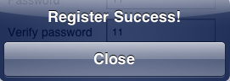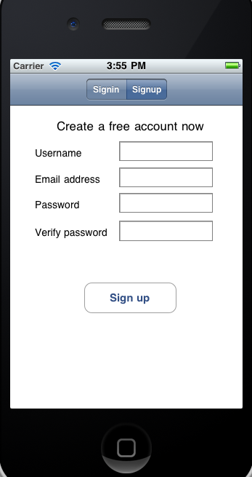

Figure 1-1 Figure 1-2

Title: 002 Signup using existed username

Precondition: You already have a registered username and the other three blanks you typed are well

Expect Result: To remind to you that the username already existed

Steps: The steps are the same as 001, but the username is used to signup before

Actual Result: it is shown in Figure 1-3

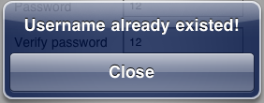

Figure 1-3

Tester: Fujing

Date: 13/06/2011

Title: 003 Signup using wrong type of email address

Precondition: The other three blanks that you typed are well

Expect Result: To remind to you that your type of email address is wrong

Steps: The steps are the same as 002, but because of your mistake, when you typed the email address, it is not in a correct type, for example, type a phone number instead of an email address

Actual Result: it is shown as Figure 1-4

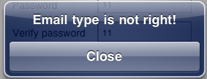

Figure 1-4

Tester: Fujing

Date: 13/06/2011

Title: 004 Password is different from the verified password

Precondition: The blanks of username and email address are filled in well

Expect Result: To remind to you that the password you type two times are different

Steps:

The steps are the same as 003, but mostly, the verified password you type is different from the password that you typed.

Actual Result: it is shown as Figure 1-5

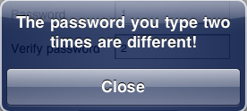

Figure 1-5

Tester: Fujing

Date: 13/06/2011

Title: 005 Missing blanks to fill in

Precondition: Forget to fill in one or more filed in the blanket

Expect Result: To tell you that which field you forget to fill in

Steps: During the process of filling in the blanks, if you did not finish and tap the Sign up button, then it will remind to you which field you are missing

Actual Result: it looks the same as Figure 1-1-Figure 1-5, only the information is different

Tester: Fujing

Date: 13/06/2011

Title: 006 Sign in successful

Precondition: You type the username and the password correctly

Expect Result: Jump to join-Krowdit screen

Steps: type your username and password, then type sign in button

Actual Result: It is shown as Figure 1-6

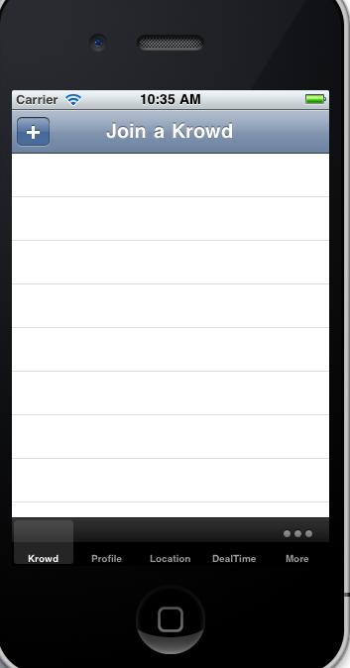

Figure 1-6

Tester: Fujing

Date: 14/06/2011

Title: 007 Missing fields to sign in

Precondition: Missing either username or password to sign in

Expect Result: To tell you which field you are missing

Steps: Switch to Sign in Screen, if you forget either username or password and try to sign in

Actual Result: You will see the information as either Figure 1-7 or Figure 1-8

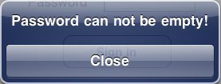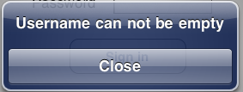

Figure 1-7 Figure 1-8

Tester: Fujing

Date: 14/06/2011

Title: 008 Sign in error

Precondition: Either username or password not found

Expect Result: To tell the user username or password error

Steps: When you type the username or password, because of careless, some information is wrong, then you type the button Sign in

Actual Result: You will see the information as Figure 1-9

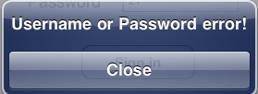

Figure 1-9

Tester: Fujing

Date: 14/06/2011